System Analysis and Design

Document history

|  |  |  |  |  |
| --- | --- | --- | --- | --- |
| Version | Date | Author | Changes | Valid from |
| 1.0 | 24-Aug-2016 | Hardik Kansara | Draft | 28-Aug-2016 |

Table of Contents

1. Introduction 3

1.1 Purpose 3

1.2 Scope 3

2. Process Model 4

3. Technical Architecture 6

3.1 System Architecture 6

3.2 Technical Architecture Design 6

3.2.1 Use Case Diagram 6

3.2.2 Class Diagram 7

3.2.3 Erd Diagram 9

3.2.4 Activity Diagram 9

3.2.5 Flow Chart 11

3.2.6 User Interface – Navigational Paths and Screen Mock-up 17

3.3 System Development/Testing Environment 19

3.3.1 Development Environment 19

3.4 Security 20

3.5 Performance 20

# 1. Introduction

## 1.1 Purpose

The project team want to attract SME (Small and Medium-Sized Enterprises) who has implemented SQL server in their infrastructure and want to know the implementation risk and verify the configuration of databases and SQL Server. The biggest opportunity with this project are first customer can see what parameters are missing with the exiting database implementation. Large number of SQL Server instances auditing is also very easy perform by this tool.

Customer will get the benefit of an audit report to tune their database parameters in well advance to overcome all the security and performance problems. Sometimes it will costly for a small business to hire a professional or a contractor to evaluate their database system because it is time consuming and costly process.

Therefore, this tool is also for a business or a customer who may not be able to hire a full time database administrator to diagnose their database system.

## 1.2 Scope

The project team will be responsible to deliver the final products for this project which are as follows:

1. A website from where a customer can download the client application and upload the database dump files.
2. A client application that will produce a dump file of the client’s database with exiting parameters values only.
3. A database evaluator tool that will generate reports from the dump files uploaded by customers.

# 2. Process Model

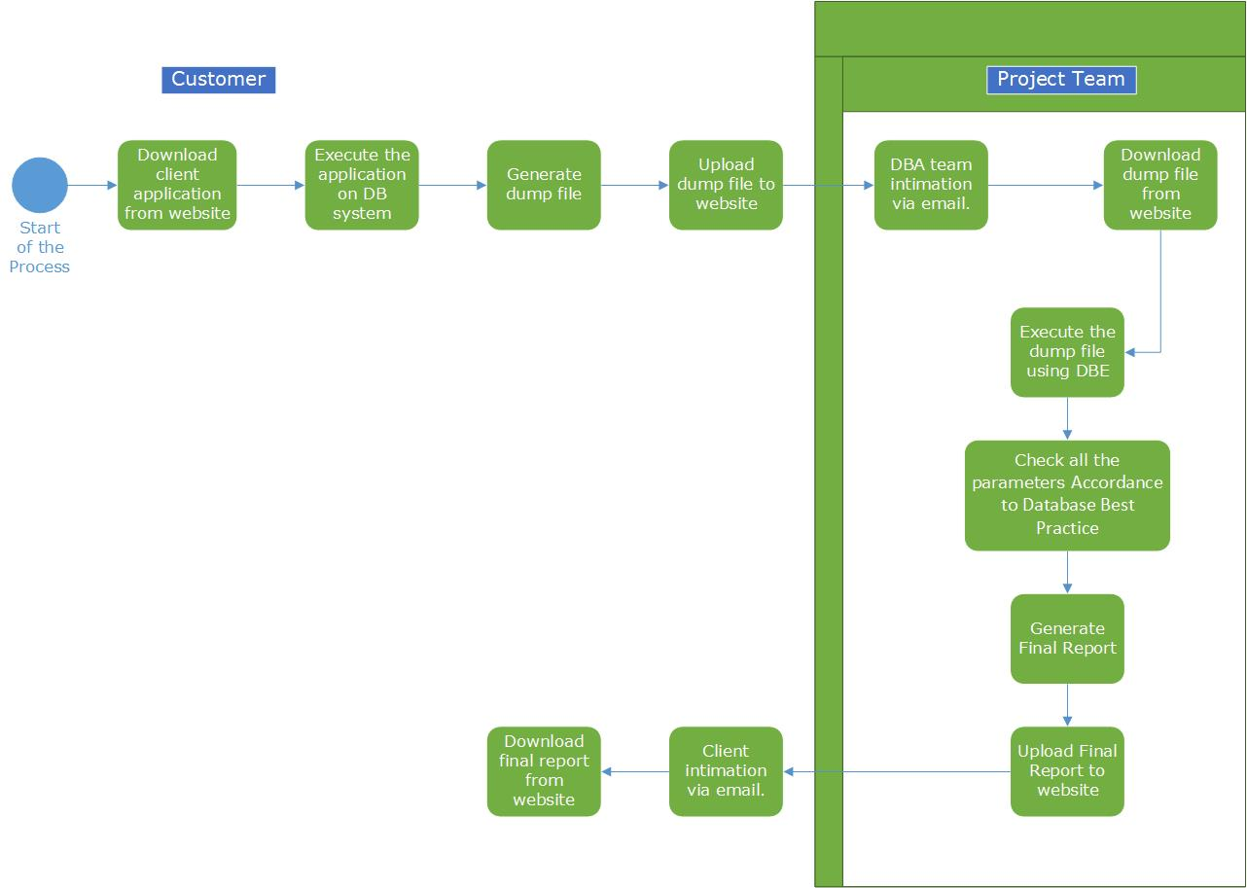

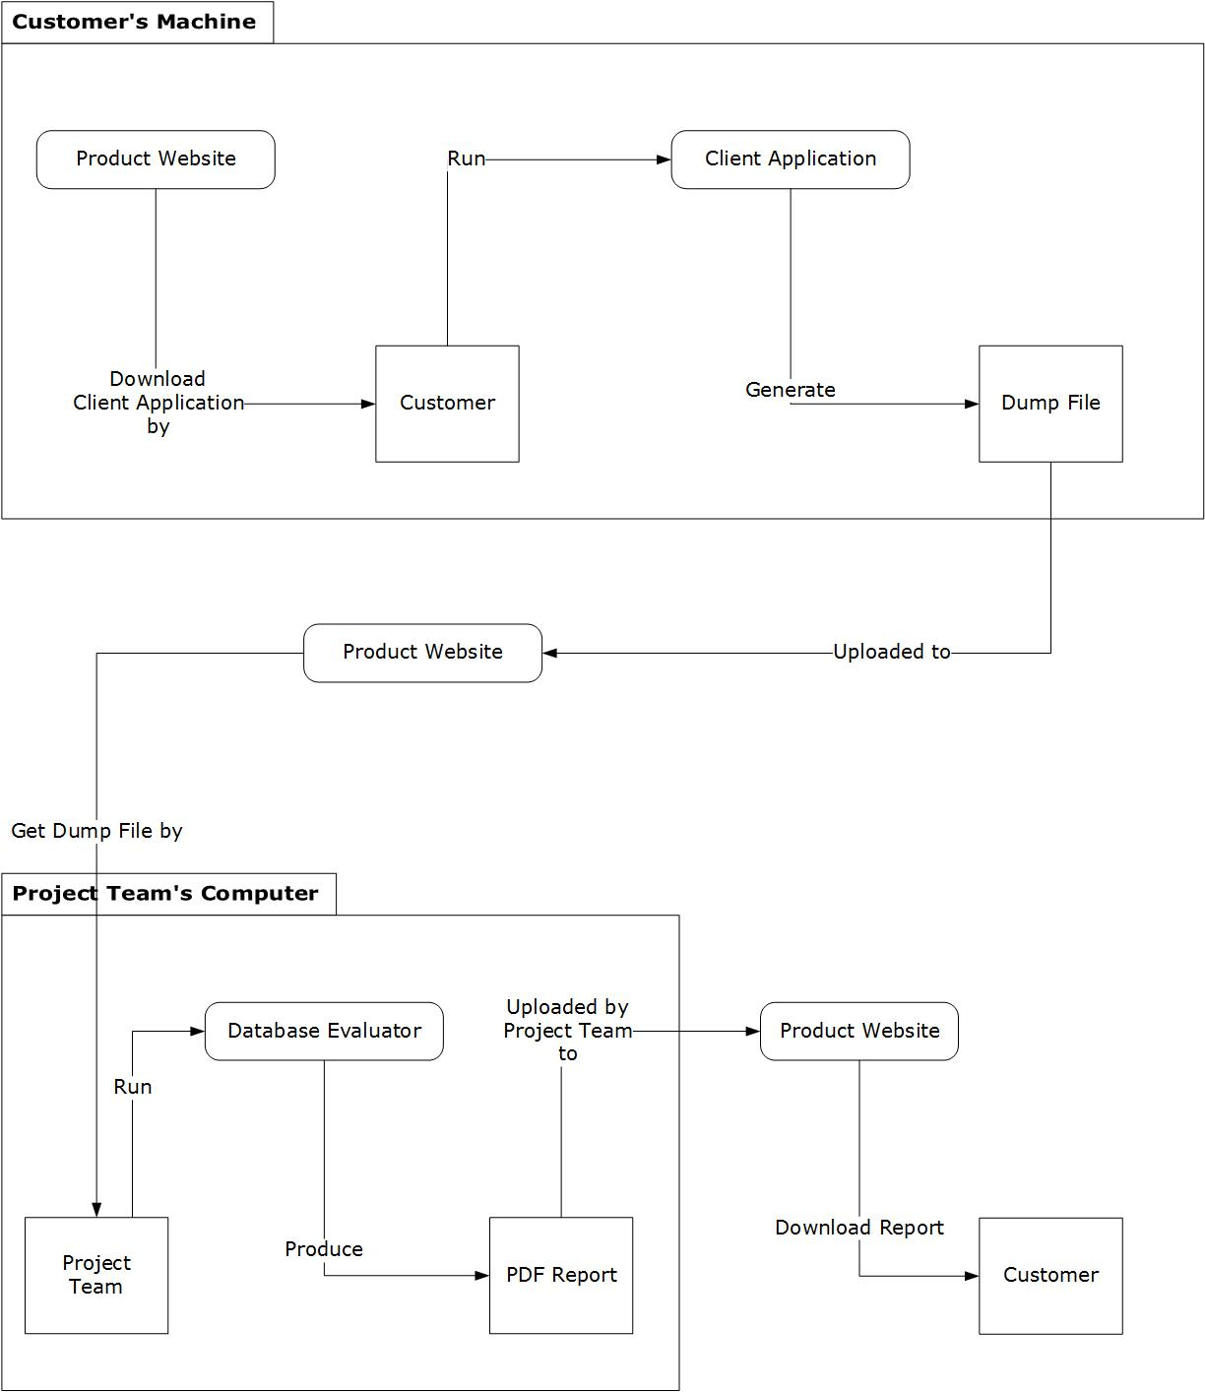

# 3. Technical Architecture

## 3.1 System Architecture

| **System Architecture Location** | C:\Users\Hardik\Documents\GitHub\Weltec-Project\1. Final Documentation\4. DSDM Documents\3. Faoundations\ SystemArchitectureDefinition.doc |
| --- | --- |

## 3.2 Technical Architecture Design

### 3.2.1 Use Case Diagram

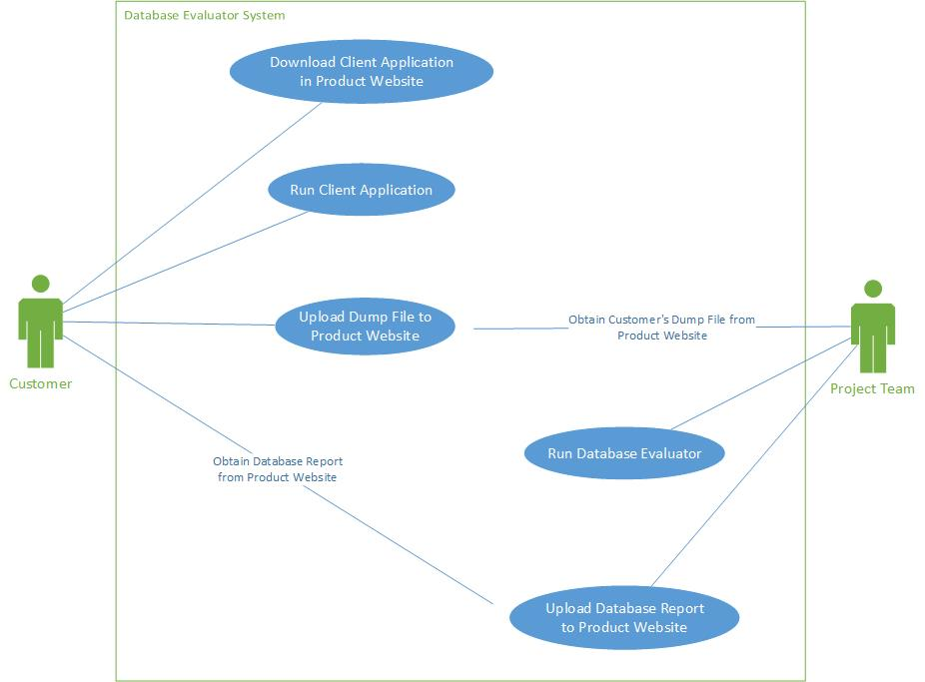

### 3.2.2 Class Diagram

**Client Application**

The client application is the one that would generate the dump file for the user.

It was created using C# Windows Forms. The Visual Studio 2015 Template was used as a base project. The .exe application is composed of the Client Application namespace. Under it, there are 3 classes: Program, SplashScreen_Form and ClientApplicationMain_Form.

|  |  |
| --- | --- |
| Class Name | Description |
| Program | The class first called when the application is started. It calls the Splash Screen and loads the Main Form when it is ready. |
| SplashScreen_Form | The Splash Screen is shown while the Main Form hasn’t finished loading yet. It is closed when the Main Form has loaded. |
| ClientApplicationMain_Form | This class is the Main Screen that the user will see. It contains all the components of the GUI. It will also handle the creation of the dump file. |

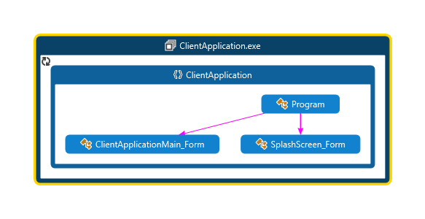

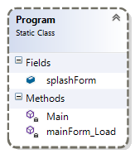

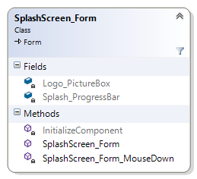

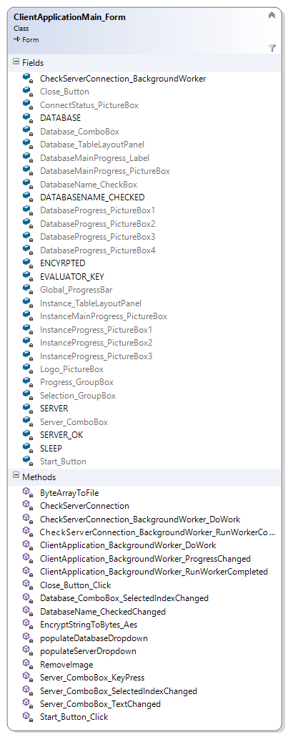

**Database Evaluator**

The database evaluator is the one that the project team would use to produce a PDF report from the dump file provided by the user.

It was also created using C# Windows Forms. The Visual Studio 2015 Template was used as a base project. The .exe application is composed of the Database Evaluator namespace. Under it, there are 2 classes: Program and DatabaseEvaluatorMain_Form.

|  |  |
| --- | --- |
| Class Name | Description |
| Program | The class first called when the application is started. It calls the Main Form when it is ready. |
| DatabaseEvaluatorMain_Form | This class is the Main Screen that the user will see. It contains all the components of the GUI. It will also handle the generation of the PDF Report. |

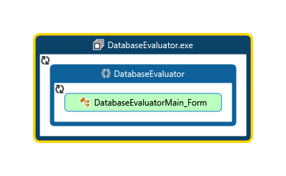

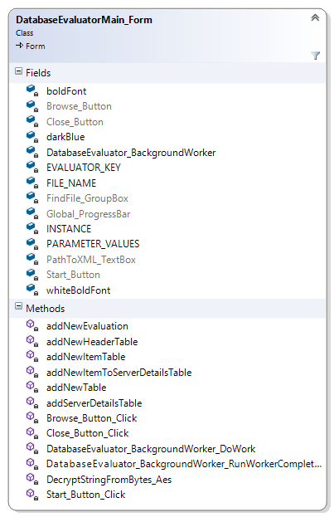

**Documentation**

For a more in depth description of the code, classes, methods and parameters used, please refer to the Code Documentation Help Files:

1. Weltec-Project\WindowsFormsApplication1\Documentation\Help\ **Database Evaluator Project Documentation.chm**
2. Weltec-Project\WindowsFormsApplication1\Documentation\Help\ **Database Evaluator Project Documentation.docx**

### 3.2.3 Erd Diagram

Database Evaluator Tables

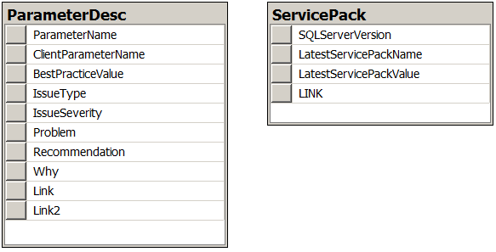

There are only two independent tables will be create to for a database evaluator application.

1. ParameterDesc : This table contains all the values and details of each parameter along with Best Practise value. Comparison and final report will be generated based on this table.
2. ServicePack : This table individually maintain the information about the latest service pack for each version of SQL Server.

DBA of the project team is responsible to maintain and update the database of the database evaluator application.

3.2.3 ERD DIAGRAM (WEBSITE)

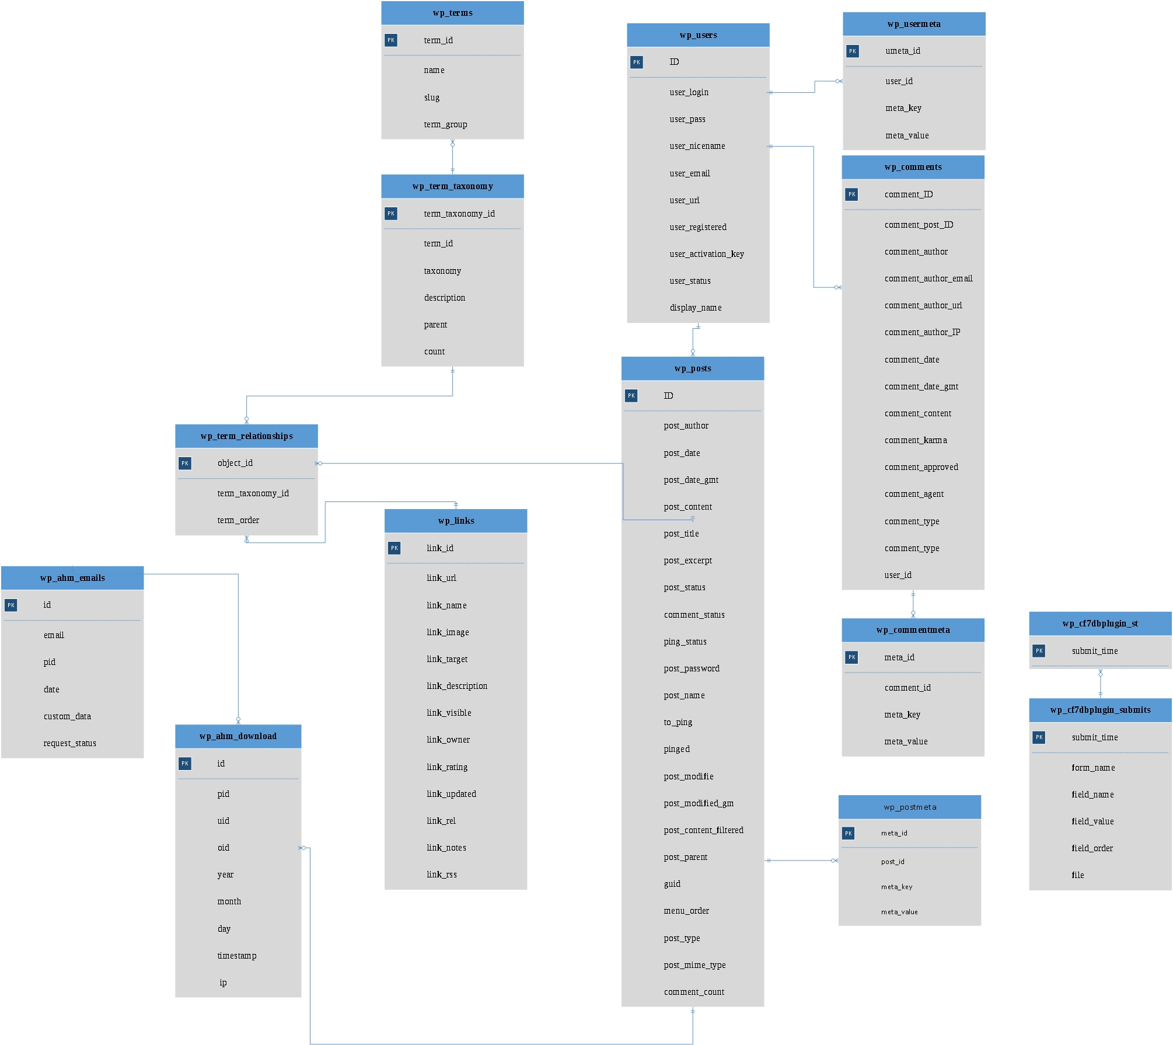

ERD DIAGRAM 1.1

ERD DIAGRAM 1.2

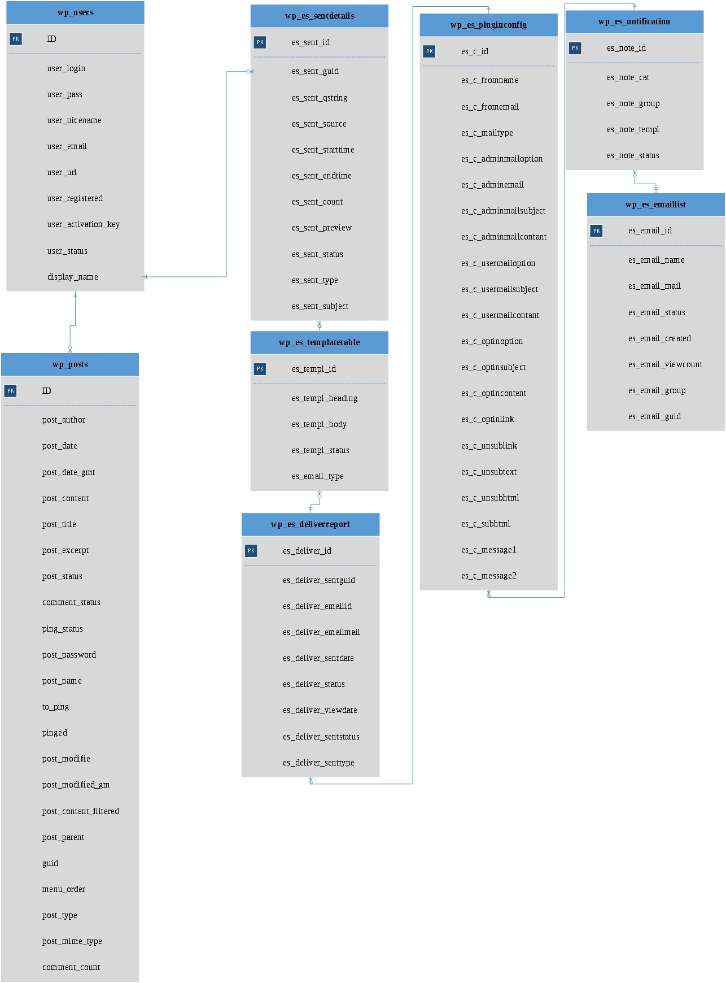

ERD Diagram for Wordpress consist of lots of table due to the reason that Wordpress uses plugins, each plugins contains an independent table which are sometimes not connected or doesnt have a relationship to other table. Mostly tables are connected to users or post table because those two are common table when Wordpress is being used to create websites.

### 3.2.4 Activity Diagram



### 3.2.5 Flow Chart

**Client Application**

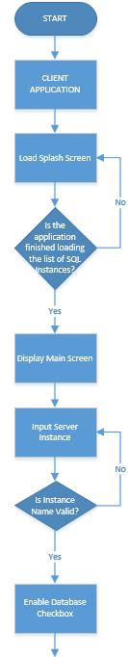

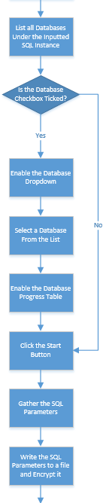

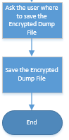

**Database Evaluator**

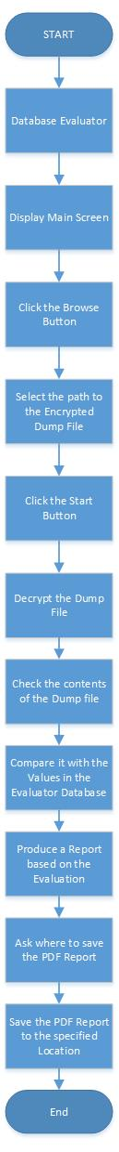

3.2.5 Database Evaluator Website Flowchart

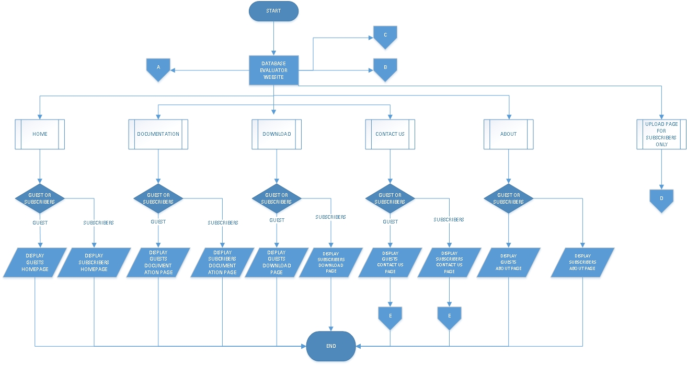The flowchart was design how the website works webpage were links to another page the connector show the relationship to each other with different shape it explains what kind of process will be used.

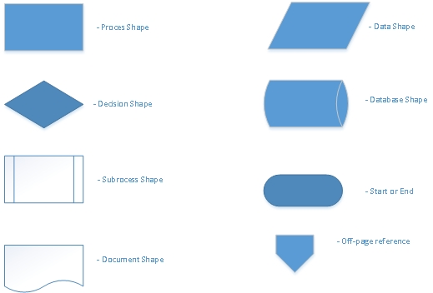

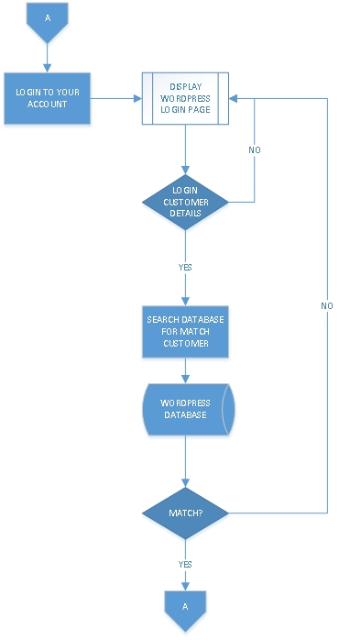

FLOWCHART SHAPES USED

**3.2.5 LOGIN PAGE (OFF CHART A)**



When the Login link was click from the Guest Page, the Login Page will show up and ask for userrname and password from user inputted details will be search and find match in the Wordpress database.

### 3.2.5 Register page (off chart b)

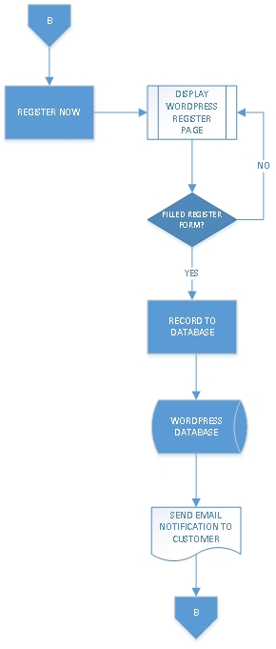

When the Register Link was click user will be redirect to Register Page and Username and Email will be ask to filled in once filled in the an email will be sent to user to verify the email if it does exist or not, together with the email is an activation key which needed to click to input user password to login to Wordpress.

3.2.5 REGISTER PAGE (OFF CHART C)

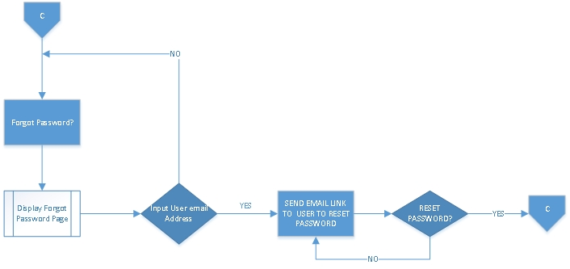

When Forgot password link was click a page asking for the subscriber email will be display and when filled out an email will be with the new link to reset subscribers password.

3.2.5 UPLOAD PAGE (OFF CHART D)

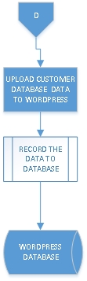

Upload page will only be available for subscribers user who have registered to the website they will be given the permission to upload their parameter and download the pdf report created by the Database Evaluator Team.

3.2.5 CONTACT US PAGE (OFF CHART E)

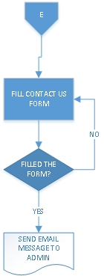

When Contact Page was click the Guest User and Subscriber can send an email to administrator.

### 3.2.6 User Interface – Navigational Paths and Screen Mock-up

**Client Application**

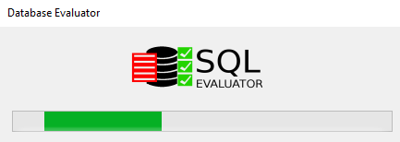

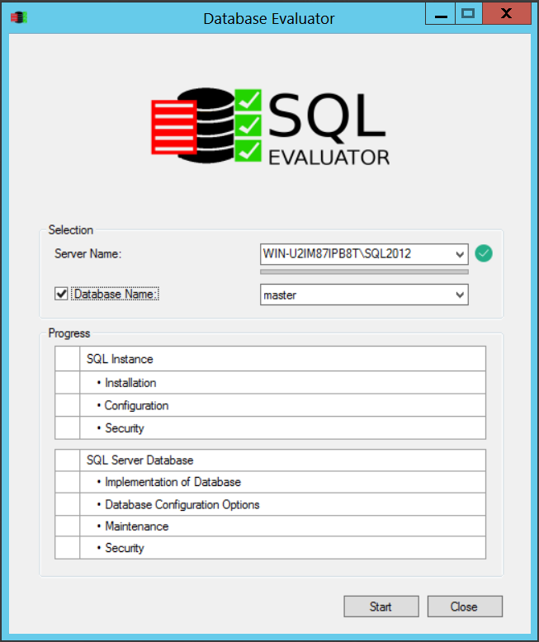

**Database Evaluator**

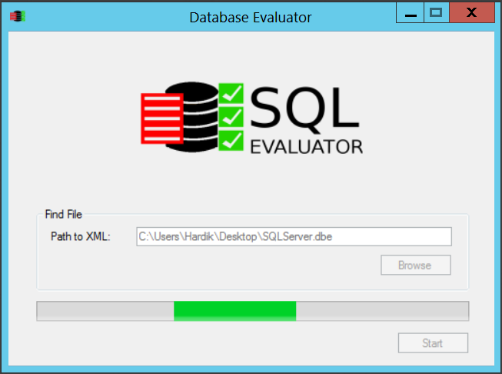

**Final Report Example**

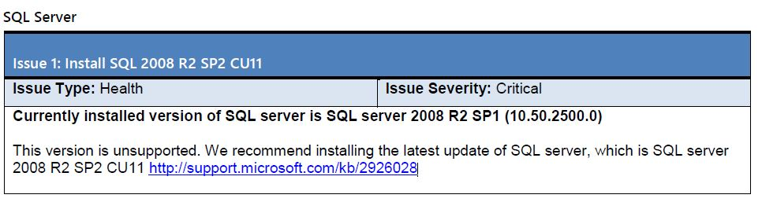

## 3.3 System Development/Testing Environment

* Client application and database evaluator will be developed in C#.
* SQL Server 2008 R2 and SQL Server 2012 will be used for creating database, generate and test SQL script.
* Website will be created using a Wordpress, PHP and MySQL.

### 3.3.1 Development Environment

Microsoft Visual Studio Enterprise 2015 Update 1

Eclipse for PHP Developers Release 4.5.2

XAMPP for Windows Version 5.6.21

PHP 5.6.21

phpMyAdmin 4.5.1

MariaDB 10.1.13

Apache 2.4.17

Git version 2.9.2

Install Shield 2015 Limited Edition

SQL Server 2016

SQL Server 2016 Management Studio

## 3.4 Security

It is planned that dump file will be encrypted for security purposes. Client application will not modify any existing parameters on customer database system.

The Website must implement basic security behaviours:

• Authentication: Login using at least a user name and a password

• Authorization: according to their profile, online customer must be granted or not to perform some specific actions. (Upload Dump File and Download Final Report)

For internet access, the following requirements are mandatory

• Confidentiality: sensitive data must be encrypted (credit card payments)

• Data integrity: Data sent across the network cannot be modified by a tier

• Auditing: Every sensitive action can be logged

• Non-repudiation: gives evidence a specific action occurred

C# and WordPress security model will be reused.

## 3.5 Performance

* Client application collects the parameter values without any error and modifying existing values.
* Encrypted dump file will be uploaded on website without any error.
* Database Evaluator will check and produce the final report without any errors.